Demand-Driven Context Building
Load only the data the active rules need
Problem, solution and developer guide
Item | Value
Scope | Rule Engine Library 3.x (leads.ruleengine.core) and the services that consume it (POC 1 DRL)
Status | PROPOSAL — not implemented. All code in this document is illustrative.
Version | 1.1 — simplified service API (plain needs() checks, no ParallelLoader)
Date | 14 October 2026
Author | K M Farhat Snigdah
Audience | Library maintainers and service developers

Contents
1. Summary
2. Background — how a request runs today
3. The problem
4. Goals and non-goals
5. Solution overview
6. Library side — design and code
7. Service (developer) side — design and code
8. Hand-written DRL rules
9. Correctness and safety rules
10. Known drawbacks and edge cases
11. Testing and observability
12. Configuration and rollout
13. When to use it — and when not
14. Appendix — API summary and glossary

1. Summary
Every business request builds a context object by running a fixed set of database lookups in buildContext() — regardless of which fields the currently active rules actually read. Rules are edited, switched on and switched off at runtime, so that fixed set drifts away from reality in both directions:
- Over-fetch: a lookup runs although no active rule reads its data — wasted database load on every request.
- Under-fetch: an admin builds a rule on a field the service never loads — the value is null and the rule silently never matches.
This document proposes demand-driven context building. The library works out, per flow, which data “roots” the active rules reference (once, when rules reload, held in memory) and exposes it as RequiredData. Before each lookup the service writes one plain check — if (need.needs("userLimit")) — so it loads only what is required, still in parallel, with a safe “load everything” fallback whenever usage cannot be proven.
Key properties: zero extra database or network calls per request for the decision itself; no change to how rules are stored; execute(...) is unchanged; fully opt-in per service and switchable off by configuration.

2. Background — how a request runs today
It helps to be precise about what is cached and what is not. Only one part of a request touches the database:
What | Where it lives at request time | DB per request?
Rules (compiled DRL) | RuleBaseProvider holds a compiled KieContainer in memory | No
Routing (request → flow → groups) | DecisionFlowResolver holds two in-memory maps | No
GlobalContext (blocked users …) | Loaded at startup by GlobalContextLoader, held in memory | No
Business facts (userLimit, product, user …) | buildContext() → repositories | Yes — every request

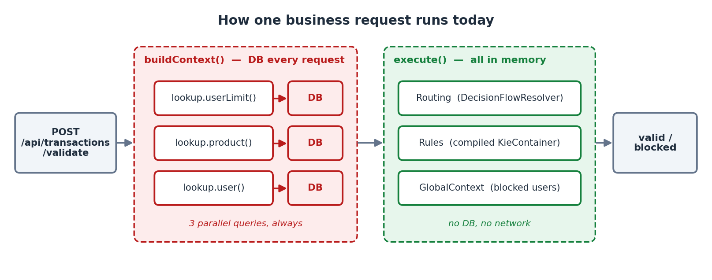
Figure 1 — Today: buildContext() hits the database on every request; execute() is entirely in memory.
Rules and routing are read from the database only at startup and on reload (when a rule, group or flow changes through the Admin API). So the per-request database cost is exactly the set of lookups in buildContext() — and that is what this proposal optimises.
Today — TransactionRuleService.buildContext() (abridged)
private ValidationContext buildContext(TransactionRequest request) {
var limitF = supplyAsync(() -> lookup.userLimit(request.getUserId()), executor);
var productF = supplyAsync(() -> lookup.product(request.getSourceAccount()), executor);
var userF = supplyAsync(() -> lookup.user(request.getUserId()), executor);
CompletableFuture.allOf(limitF, productF, userF).join(); // always all three

ValidationContext context = new ValidationContext();
context.setUserId(request.getUserId());
context.setUser(userF.join());
context.setTransaction(toFact(request));
context.setUserLimit(limitF.join());
context.setProduct(productF.join());
return context;
}

3. The problem

3.1 Static code, dynamic rules
The lookups are hard-coded Java. The rules are data that business users change at runtime. Nothing connects the two, so the lookups cannot follow the rules.

3.2 Worked example — the transfer flow
Which data root each seeded transfer rule reads:
# | Rule | Group | Roots read
1 | Block transaction for a blocked user | COMMON (DRL) | none (userId + GlobalContext)
2 | Block if KYC not verified | COMMON (DRL) | user
3 | Block over-limit debit-restricted BDT | TRANSFER | transaction, product, userLimit
4 | High-value or cross-border transfer | TRANSFER | transaction
5 | Block rapid high-value agent transfers | VELOCITY | transaction
6 | Layered channel & geo screen | VELOCITY | transaction
7 | High-value cross-border non-BDT | COMPLIANCE | transaction
8 | Deep-nested compliance check | COMPLIANCE | transaction, product, userLimit

Situation | Roots needed | DB lookups needed | Today runs | Wasted
All 8 rules active | transaction, user, product, userLimit | 3 | 3 | 0
Rules #3 and #8 switched off | transaction, user | 1 (user) | 3 | 2
#3, #8 and KYC (#2) switched off | transaction | 0 | 3 | 3

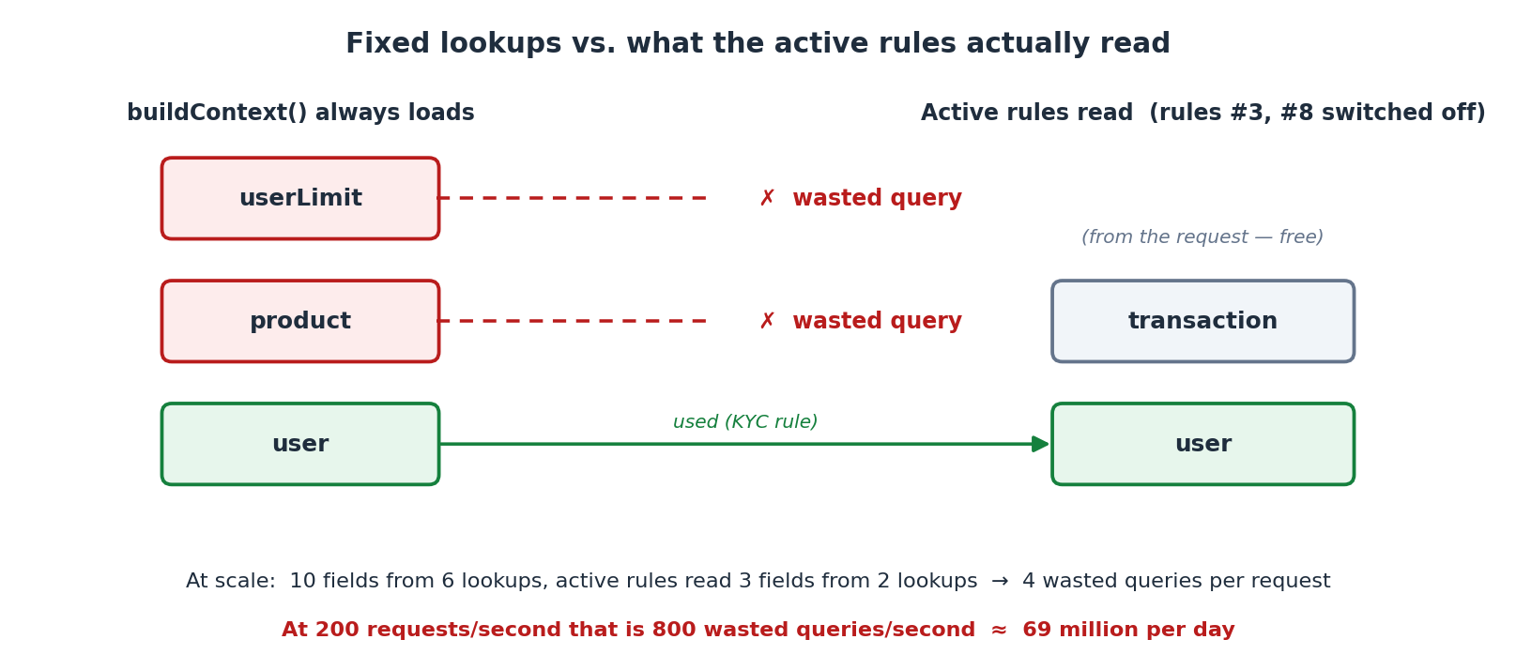
Figure 2 — With rules #3 and #8 switched off, two of the three lookups are wasted on every request.

3.3 At scale
Take a richer flow: 10 catalog fields coming from 6 lookups, while the active rules read 3 fields from 2 lookups. That is 4 wasted queries per request. At 200 requests per second: 4 × 200 = 800 wasted queries per second, or 800 × 86,400 ≈ 69 million per day — connection-pool pressure and database CPU for data nobody reads.

3.4 The mirror risk — under-fetch
The obvious “fix” — delete the lookups you think are unused — creates the opposite bug. Tomorrow an admin builds a rule on userLimit.limit; the service no longer loads it; the value is null; the rule never matches and nobody is told.
Over-fetch wastes resources. Under-fetch is a correctness bug. In a banking rule engine a missed block is far worse than an extra query, so any optimisation must never under-fetch.

3.5 A note on latency
The lookups already run in parallel on virtual threads, so response time ≈ the slowest lookup, not the sum. An unused lookup usually costs throughput and database load rather than latency — unless it happens to be the slowest one, or it is a remote call to another service. That is where the savings are largest.

4. Goals and non-goals

Goals
- G1 Load only the data roots that the active rules of the flow reference.
- G2 Never under-fetch: if usage cannot be proven, load everything.
- G3 Zero extra database or network cost per request for deciding what to load.
- G4 No change to rule storage, the Admin API contract for rules, or execute(...).
- G5 Opt-in per service, switchable off by configuration, adoptable incrementally.

Non-goals
- Lazy loading inside Drools (a getter that hits the database during rule evaluation). It serialises lookups, runs I/O inside the rule session and breaks transaction boundaries.
- Parsing arbitrary hand-written DRL to discover the fields it reads. Too fragile; DRL rules declare their needs instead (section 8).
- Caching business data between requests. A separate concern with its own invalidation rules.

5. Solution overview
Split the responsibility along the existing library / service boundary. The library knows the rules, so it decides what is needed. The service knows its domain, so it knows how to load each piece. The two meet through one small value object, RequiredData.
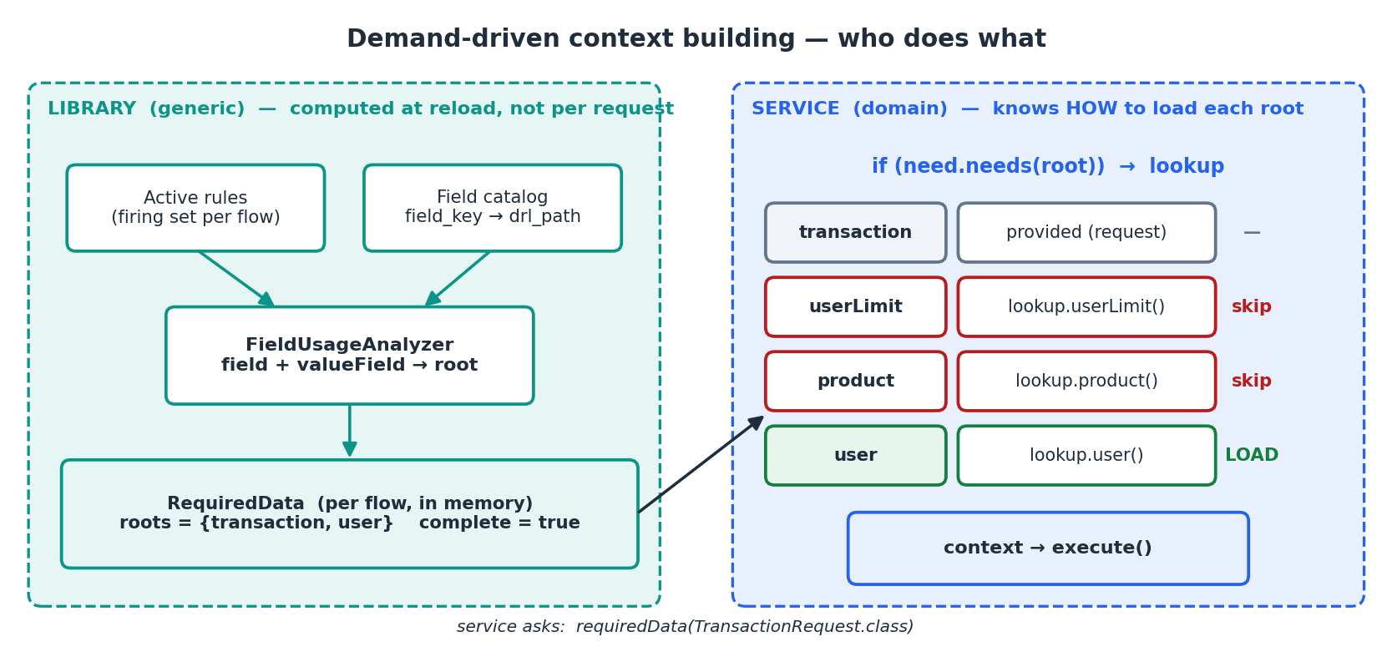
Figure 3 — The library computes RequiredData at reload; the service checks needs(root) before each lookup.

Vocabulary
Term | Meaning | Example
field key | What a builder condition stores in its tree | userLimit.limit
drl path | Real property path used in generated DRL (from the catalog) | userLimit!.limit
root | First segment of the drl path — one root = one thing to load | userLimit
firing set | Active rules in the flow's active groups + active shared groups | rules #1–#8
complete | true = usage proven; false = unknown, load everything | false if a DRL rule has no hint

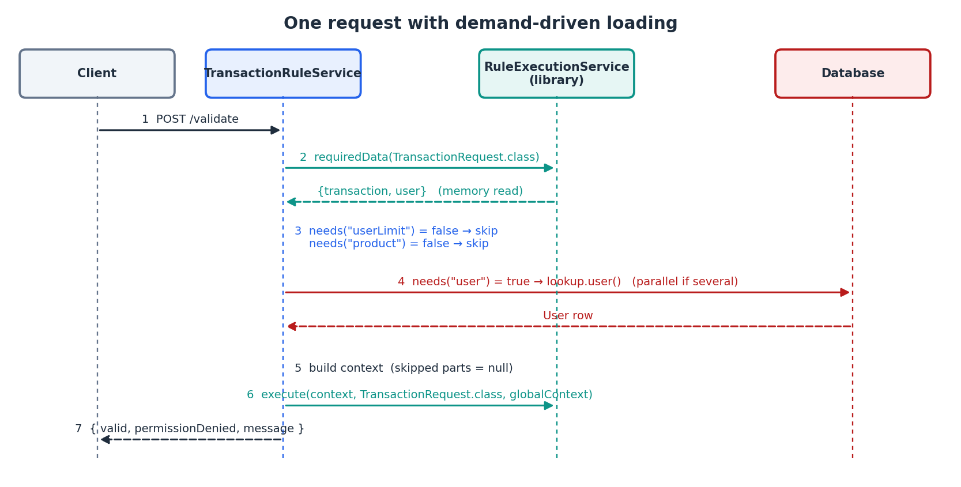
Figure 4 — One request: an in-memory question, then only the needed lookups, still in parallel.

6. Library side — design and code
Three small additions plus one method. Nothing runs at request time except a map read and a set lookup. There is no helper class for the service to learn — the service keeps its own CompletableFuture code.
Component | Package | Responsibility
RequiredData | dto | Immutable answer: roots, fields, known roots, complete flag; needs(root)
FieldUsageAnalyzer | service | Reads one rule and returns the fields it uses (or “unknown”)
RequiredDataResolver | service | Builds RequiredData for every flow at reload; serves it from memory

6.1 RequiredData — the answer object
leads.ruleengine.core.dto.RequiredData
/** What a flow's active rules need. Immutable; built at reload, read per request. */
public record RequiredData(String flowCode,
Set<String> roots, // roots the active rules read
Set<String> fields, // full field keys, for the admin endpoint
Set<String> knownRoots, // every root this flow can have (catalog + hints)
boolean complete) { // false = usage not proven

private static final Logger log = LoggerFactory.getLogger(RequiredData.class);

/** Usage could not be proven: the caller must load everything. */
public static RequiredData everything(String flowCode, Set<String> knownRoots) {
return new RequiredData(flowCode, Set.of(), Set.of(), knownRoots, false);
}

/** No active rule in this flow: nothing to load. */
public static RequiredData nothing(String flowCode, Set<String> knownRoots) {
return new RequiredData(flowCode, Set.of(), Set.of(), knownRoots, true);
}

/** Same flow, but "load everything" - used by shadow mode and the off switch. */
public RequiredData asEverything() {
return everything(flowCode, knownRoots);
}

/**
* The one method a service developer calls.
* true -> load this root. false -> skip it, no active rule reads it.
* A name that is not a root of this flow (typo) is logged and answered true:
* a typo can only over-fetch, never under-fetch, and never fails a request.
*/
public boolean needs(String root) {
if (!knownRoots.isEmpty() && !knownRoots.contains(root)) {
log.error("needs(\"{}\") - not a root of flow {}. Known roots: {}. Loading it anyway.",
root, flowCode, knownRoots);
return true;
}
return !complete || roots.contains(root);
}
}

Why a typo answers true: if needs("userLimt") returned false, that data would never load and the rule would silently stop working — the under-fetch bug again. Answering true keeps the request correct; the ERROR log line makes the typo visible on the first request, and the service test in section 11.3 fails the build.

6.2 FieldUsageAnalyzer — what does one rule read?
For a BUILDER rule it walks the condition tree and collects both field and valueField. For a DRL rule it reads an optional // @requires: hint (section 8). Anything it cannot prove returns empty, which means “unknown”.
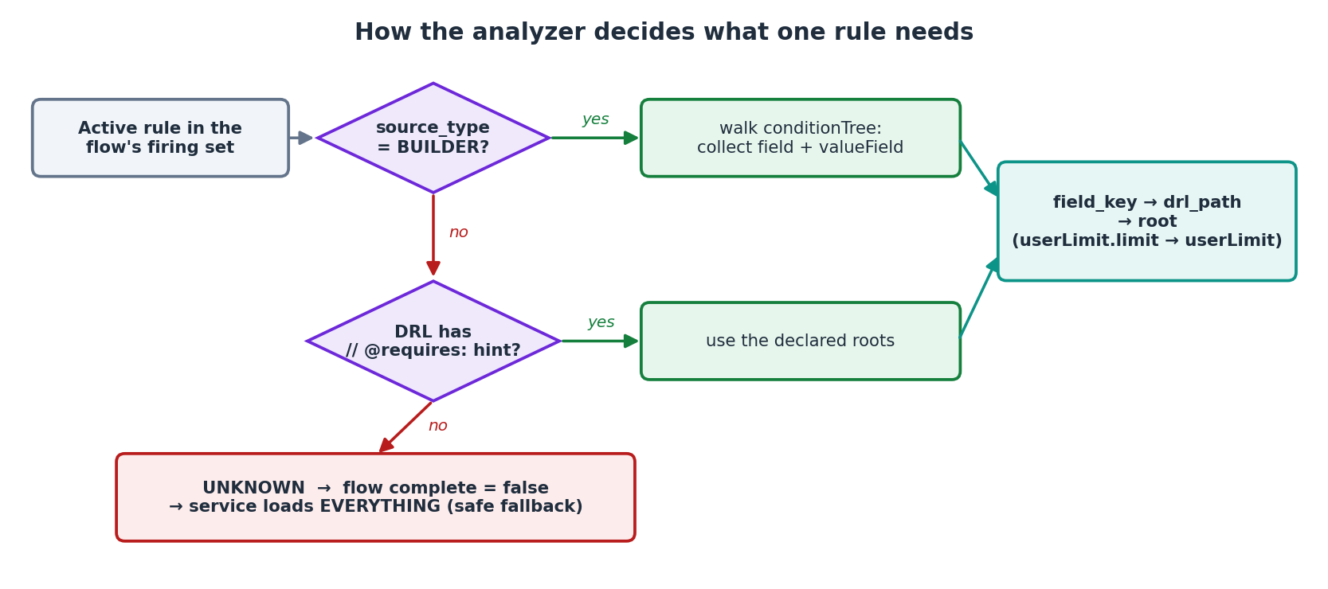
Figure 5 — Per-rule decision. Unknown is never guessed: it switches the whole flow to “load everything”.
leads.ruleengine.core.service.FieldUsageAnalyzer
@Component
public class FieldUsageAnalyzer {

private static final Pattern REQUIRES =
Pattern.compile("^\\s*//\\s*@requires\\s*:\\s*(.*)$", Pattern.MULTILINE);
private final ObjectMapper objectMapper = new ObjectMapper();

/** Field keys / paths the rule reads, or empty if that cannot be proven. */
public Optional<Set<String>> fieldsOf(RuleDefinition rule) {
if (RuleDefinition.SOURCE_BUILDER.equals(rule.getSourceType())) {
try {
BuilderRuleSpec spec = objectMapper.readValue(
rule.getSourceJson(), BuilderRuleSpec.class);
Set<String> out = new TreeSet<>();
walk(spec.conditionTree, out);
return Optional.of(out);
} catch (Exception e) {
return Optional.empty(); // unreadable -> unknown
}
}
Matcher hint = REQUIRES.matcher(rule.getDrlText());
if (!hint.find()) {
return Optional.empty(); // DRL without hint -> unknown
}
String list = hint.group(1).trim();
if (list.equalsIgnoreCase("none")) {
return Optional.of(Set.of());
}
return Optional.of(Arrays.stream(list.split("\\s*,\\s*"))
.filter(s -> !s.isBlank())
.collect(Collectors.toCollection(TreeSet::new)));
}

private void walk(ConditionNode node, Set<String> out) {
if (node instanceof ConditionLeaf leaf) {
out.add(leaf.field);
if (leaf.valueField != null && !leaf.valueField.isBlank()) {
out.add(leaf.valueField); // field-to-field compare
}
} else if (node instanceof ConditionGroup group && group.children != null) {
group.children.forEach(child -> walk(child, out));
}
}
}

6.3 RequiredDataResolver — build once, read many
At reload it computes RequiredData for every flow and swaps a single immutable map. Requests only call forFlow(id) — a map read. The firing set mirrors exactly what DecisionFlowResolver focuses at runtime: active shared groups plus the flow's own active groups.
leads.ruleengine.core.service.RequiredDataResolver
@Component
public class RequiredDataResolver {

private final RuleFlowRepository flows;
private final RuleGroupRepository groups;
private final RuleDefinitionRepository rules;
private final RuleFieldCatalogRepository catalog;
private final FieldUsageAnalyzer analyzer;

private volatile Map<Long, RequiredData> byFlow = Map.of();

// constructor injection omitted for brevity

/** Per-request call: a map read, no I/O. Unknown flow -> load everything. */
public RequiredData forFlow(Long flowId) {
return byFlow.getOrDefault(flowId, RequiredData.everything("?", Set.of()));
}

@Transactional(readOnly = true) // rule.getGroup() is LAZY
public synchronized void reload() {
Map<String, String> pathByKey = catalog.findAll().stream().collect(
toMap(RuleFieldCatalog::getFieldKey, RuleFieldCatalog::getDrlPath, (a, b) -> a));
Map<Long, List<RuleDefinition>> rulesByGroup = rules.findByActiveTrue().stream()
.collect(groupingBy(r -> r.getGroup().getId()));
List<RuleGroup> all = groups.findAll();
List<RuleGroup> shared = all.stream()
.filter(g -> g.isShared() && g.isActive()).toList();

Map<Long, RequiredData> fresh = new HashMap<>();
for (RuleFlow flow : flows.findAll()) {
Set<String> known = knownRoots(flow.getId(), pathByKey, rulesByGroup);
if (!flow.isActive()) { // inactive flow fires nothing
fresh.put(flow.getId(), RequiredData.nothing(flow.getFlowCode(), known));
continue;
}
List<RuleGroup> firing = new ArrayList<>(shared);
all.stream().filter(g -> !g.isShared() && g.isActive()
&& g.getFlow().getId().equals(flow.getId()))
.forEach(firing::add);
fresh.put(flow.getId(),
analyse(flow.getFlowCode(), firing, rulesByGroup, pathByKey, known));
}
this.byFlow = Map.copyOf(fresh); // atomic swap
}

private RequiredData analyse(String flowCode, List<RuleGroup> firing,
Map<Long, List<RuleDefinition>> rulesByGroup,
Map<String, String> pathByKey, Set<String> known) {
Set<String> fields = new TreeSet<>();
for (RuleGroup g : firing) {
for (RuleDefinition rule : rulesByGroup.getOrDefault(g.getId(), List.of())) {
Optional<Set<String>> used = analyzer.fieldsOf(rule);
if (used.isEmpty()) {
return RequiredData.everything(flowCode, known); // cannot prove -> all
}
fields.addAll(used.get());
}
}
Set<String> roots = fields.stream().map(f -> rootOf(f, pathByKey))
.collect(Collectors.toCollection(TreeSet::new));
return new RequiredData(flowCode, roots, fields, known, true);
}

/** Every root the flow can have: its catalog rows (own + shared) plus @requires hints. */
private Set<String> knownRoots(Long flowId, Map<String, String> pathByKey,
Map<Long, List<RuleDefinition>> rulesByGroup) {
Set<String> known = new TreeSet<>();
catalog.findForFlow(flowId).forEach(f -> known.add(rootOf(f.getFieldKey(), pathByKey)));
rulesByGroup.values().stream().flatMap(List::stream)
.filter(r -> RuleDefinition.SOURCE_DRL.equals(r.getSourceType()))
.map(analyzer::fieldsOf).flatMap(Optional::stream).flatMap(Set::stream)
.forEach(f -> known.add(rootOf(f, pathByKey)));
return known;
}

/** "userLimit.limit" -> catalog path "userLimit!.limit" -> root "userLimit". */
static String rootOf(String fieldKey, Map<String, String> pathByKey) {
String path = pathByKey.getOrDefault(fieldKey, fieldKey).replace("!", "");
int dot = path.indexOf('.');
return dot < 0 ? path : path.substring(0, dot);
}
}

6.4 Keeping it fresh — order matters
RequiredData must change whenever the firing set changes: startup, a rule saved, edited, deleted or toggled, a group or flow toggled or deleted. The two existing reload points call RequiredDataResolver.reload() — and they call it before the new rules or routing go live.
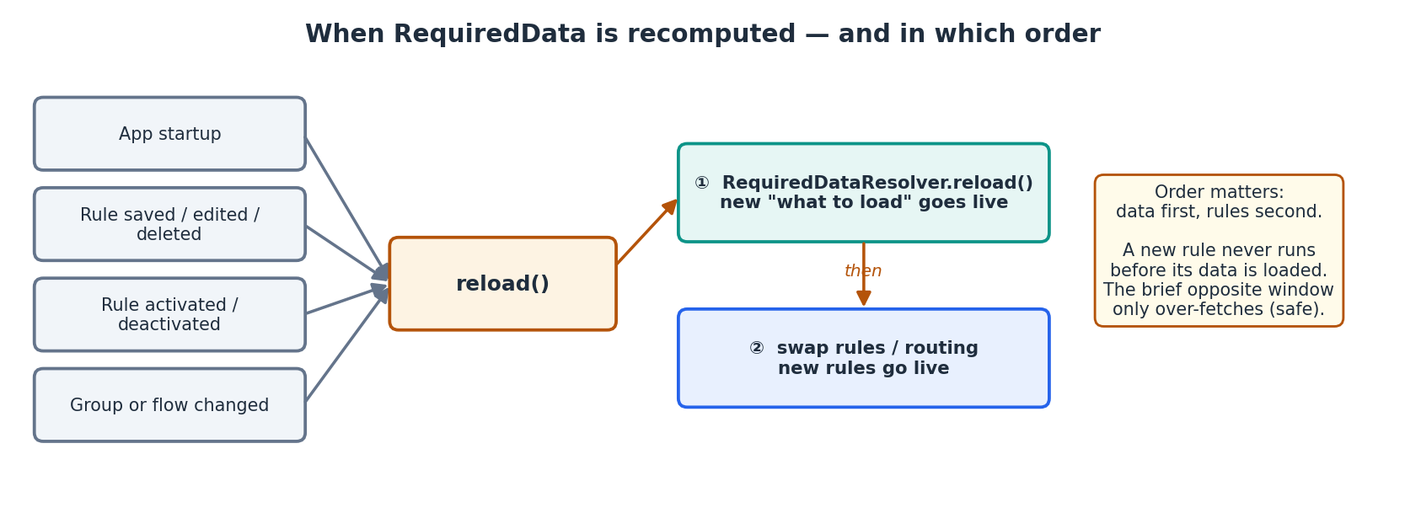
Figure 6 — Data first, rules second: new requests always load a new rule's data (one request already in flight is the exception — see D4 in section 10).
RuleBaseProvider.reload() — one added line, placed before the swap
public synchronized void reload() {
List<RuleDefinition> active = ruleDefinitionRepository.findByActiveTrue();
KieContainer fresh = build(active);

requiredData.reload(); // (1) new "what to load" goes live first

KieContainer old = this.container;
this.container = fresh; // (2) then the new rules go live
if (old != null) {
old.dispose();
}
}

Add the same line in DecisionFlowResolver.reload() just before it swaps its two maps, so activating a group or flow behaves the same way. During the brief window the other way round (a rule removed, old RequiredData still live) the service merely over-fetches — which is safe.

6.5 Public API
RuleExecutionService — one new method (execute() is unchanged)
/** What the active rules of the flow routed from this request class need. No I/O. */
public RequiredData requiredData(Class<?> requestType) {
Long flowId = flowResolver.flowFor(requestType.getName());
RequiredData real = requiredDataResolver.forFlow(flowId);
if (!properties.getRequiredData().isEnabled()) {
return real.asEverything(); // feature off: today's behaviour
} // (typo check in needs() still works)
if (properties.getRequiredData().isShadow()) {
log.debug("[shadow] {} would load {}", real.flowCode(), real.roots());
return real.asEverything(); // still load all
}
return real;
}

Admin endpoint — inspect it at any time: GET /admin/flows/{flowCode}/required-data
{
"flowCode": "TRANSFER_TRANSACTION",
"roots": ["transaction", "user"],
"fields": ["transaction.amount", "transaction.channel", "user"],
"knownRoots": ["product", "transaction", "user", "userId", "userLimit"],
"complete": true
}

6.6 What the library does NOT provide
An earlier draft had a ParallelLoader helper that ran the lookups for the service. It is dropped. The service already knows how to run lookups in parallel; adding one if in front of each lookup is simpler, easier to read and debug, and keeps the library small. The library's only job is to answer needs(root).

7. Service (developer) side — design and code
The feature is opt-in per service. A developer can keep today's code untouched, or add one needs(...) check in front of each lookup. Both styles work with the same library version; the controller, the request/response DTOs, the context classes and execute(...) stay the same either way.

7.1 Option A — keep today's code (no change)
A service that never calls requiredData(...) keeps working exactly as before: it loads everything and runs the rules. Nothing in the library forces the new style, and nothing breaks when the library is upgraded. Choose this when the lookups are cheap.
TransactionRuleService — today's style, still valid
public TransactionResponse validate(TransactionRequest request) {
ValidationContext context = buildContext(request);
ruleEngine.execute(context, TransactionRequest.class, globalContext);
return new TransactionResponse(context.isValid(),
context.isPermissionDenied(), context.getValidationMessage());
}

private ValidationContext buildContext(TransactionRequest request) {
var limitF = supplyAsync(() -> lookup.userLimit(request.getUserId()), lookupExecutor);
var productF = supplyAsync(() -> lookup.product(request.getSourceAccount()),
lookupExecutor);
var userF = supplyAsync(() -> lookup.user(request.getUserId()), lookupExecutor);

try {
CompletableFuture.allOf(limitF, productF, userF).join(); // parallel, await all
} catch (CompletionException e) {
if (e.getCause() instanceof ResponseStatusException rse) throw rse; // keep the 422
throw e;
}

ValidationContext context = new ValidationContext();
context.setUserId(request.getUserId()); // for the COMMON blocked-user rule
context.setUser(userF.join()); // for the COMMON KYC rule
context.setTransaction(toFact(request));
context.setUserLimit(limitF.join());
context.setProduct(productF.join());
return context;
}

Question | Answer
Does it still work after the library upgrade? | Yes — execute(...) is unchanged
Does it get the saving? | No — it always runs all three lookups (today's behaviour)
Can it ever under-fetch? | No — everything is always loaded
Can one service use A and another use B? | Yes — the choice is per service, even per flow

7.2 Option B — demand-driven (one check per lookup)
The same code as Option A with one change: ask the library once, then put need.needs("root") in front of each lookup. The root name is the first part of the catalog drl_path — userLimit!.limit → "userLimit". How the data is loaded (database, another service, cache) is entirely the developer’s choice; the library only answers yes or no.
TransactionRuleService — demand-driven style (illustrative)
@Service
public class TransactionRuleService {

private final RuleExecutionService ruleEngine;
private final GlobalContext globalContext;
private final ExecutorService lookupExecutor;
private final TransferLookupService lookup;

// constructor unchanged

public TransactionResponse validate(TransactionRequest request) {
ValidationContext context = buildContext(request);
ruleEngine.execute(context, TransactionRequest.class, globalContext);
return new TransactionResponse(context.isValid(),
context.isPermissionDenied(), context.getValidationMessage());
}

private ValidationContext buildContext(TransactionRequest request) {
RequiredData need = ruleEngine.requiredData(TransactionRequest.class); // memory, no DB

// same parallel code as today - each lookup now has a needs() check in front
CompletableFuture<UserLimit> limitF = need.needs("userLimit")
? supplyAsync(() -> lookup.userLimit(request.getUserId()), lookupExecutor)
: completedFuture(null);

CompletableFuture<Product> productF = need.needs("product")
? supplyAsync(() -> lookup.product(request.getSourceAccount()), lookupExecutor)
: completedFuture(null);

CompletableFuture<User> userF = need.needs("user")
? supplyAsync(() -> lookup.user(request.getUserId()), lookupExecutor)
: completedFuture(null);

try {
CompletableFuture.allOf(limitF, productF, userF).join();
} catch (CompletionException e) {
if (e.getCause() instanceof ResponseStatusException rse) throw rse; // keep the 422
throw e;
}

ValidationContext context = new ValidationContext();
context.setUserId(request.getUserId()); // from the request - always set
context.setTransaction(toFact(request)); // from the request - always set
context.setUserLimit(limitF.join()); // null when no active rule reads it
context.setProduct(productF.join());
context.setUser(userF.join());
return context;
}

// toFact(...) unchanged
}

Without parallel lookups it is even simpler — one if per root:
Sequential variant
RequiredData need = ruleEngine.requiredData(TransactionRequest.class);

if (need.needs("userLimit")) {
context.setUserLimit(lookup.userLimit(request.getUserId()));
}
if (need.needs("product")) {
context.setProduct(lookup.product(request.getSourceAccount()));
}
if (need.needs("user")) {
context.setUser(lookup.user(request.getUserId()));
}

Error handling is unchanged: the same join() calls and the same exception unwrapping as Option A. Data that comes from the request itself (transaction, userId) is always set — it costs nothing, so it needs no check.

7.3 Before and after
Aspect | Option A (today) | Option B (demand-driven)
Lookups per request | Always 3 | 0–3, exactly what the active rules read
Cost of deciding | — | One in-memory map read
Admin builds a rule on a new root | Value silently null | Root appears in RequiredData at reload and is loaded
Admin switches rules off | Lookups keep running | Unused lookups stop at the next reload
Hand-written DRL rule | n/a | Needs a // @requires: hint, otherwise the flow loads everything
Service code | Option A | Option B: same lookups, one needs() check in front of each
Code in the controller / DTOs / context | — | Unchanged

7.4 Checklist — adding a new field later
- Add a catalog row with the correct drl_path (use !. for nullable parents).
- If its root is new: write the lookup (Option A: as today; Option B: with a need.needs("newRoot") check in front) and add the root to the test set in section 11.3.
- If it comes from the request, just set it on the context — no check needed.
- Run the service test (section 11.3). It fails if a catalog root has no lookup in the service.

8. Hand-written DRL rules

8.1 Why they matter
Both shared COMMON rules (blocked user, KYC) are hand-written DRL. Shared rules belong to every flow's firing set. Without any extra information the analyzer cannot prove what they read, so every flow becomes “unknown” and loads everything — the optimisation would save nothing today.

8.2 The @requires hint
A DRL rule declares the roots (or paths) it reads in one comment line. It is plain DRL, so the engine ignores it; only the analyzer reads it. No schema change.
Blocked user — reads userId and GlobalContext only, nothing to load
// @requires: none
package com.example.droolspoc.rules;

import com.example.droolspoc.model.RuleContext;
import com.example.droolspoc.context.data.BlockedUsers;

global leads.ruleengine.core.context.GlobalContext globalContext;

rule "Block transaction for a blocked user"
agenda-group "COMMON"
salience 100
when
$ctx : RuleContext()
eval(globalContext.get(BlockedUsers.class).isBlocked($ctx.getUserId()))
then
$ctx.setValid(false);
$ctx.setPermissionDenied(true);
$ctx.setValidationMessage("Blocked: user is blocked");
drools.halt();
end

KYC — reads user.kycVerified
// @requires: user
package com.example.droolspoc.rules;
...
when
$ctx : RuleContext(user != null, user.kycVerified == false)
...

Hint | Meaning
// @requires: none | Reads no loadable data (request fields / GlobalContext only)
// @requires: user | Needs the user root
// @requires: user, userLimit.limit | Several entries; a path is reduced to its root
(no hint) | Unknown → the flow loads everything (today's behaviour)

8.3 Alternatives considered
- Convert KYC to a builder rule. Works (it is a plain field check) and needs no hint. Blocked-user still needs DRL because of the GlobalContext call.
- A REQUIRED_ROOTS column on RULE_DEFINITION. Cleaner to query, but a schema change and one more field to keep in sync. The comment keeps the declaration next to the code it describes.
- Parse the DRL patterns automatically. Rejected — fragile across eval(), from, accumulate and functions.
Risk: a wrong hint can under-fetch. Mitigations: review hints with the rule, the integration test in section 11, and rule-engine.required-data.trust-drl-hints=false to ignore all hints instantly.

9. Correctness and safety rules
1. Prove it or load everything. Any rule whose usage cannot be proven marks the whole flow complete=false.
2. Count both sides of a comparison. valueField is collected along with field.
3. Count shared rules in every flow. Active shared (COMMON) groups are part of every active flow's firing set.
4. Data first, rules second. RequiredData is swapped before new rules or routing go live (section 6.4).
5. A typo can only over-fetch. needs() with a name that is not a root of the flow logs an ERROR and answers true.
6. Never block a request. An exception while analysing a flow falls back to everything() and is logged; requests are never failed by this feature.
7. Skipped means unread. A root is null only when no active rule reads it, so skipping cannot change a decision.
8. Inactive flow loads nothing. It fires no rules, so RequiredData is nothing().

10. Known drawbacks and edge cases
No design is free. These are the real weak points of the simplified version, and how each one is handled.
# | Drawback | Effect | Handling
D1 | Typo in a root name, e.g. needs("userLimt") | Could skip data a rule needs | needs() answers true + ERROR log; test 11.3
D2 | Developer forgets the needs() check on a lookup | That lookup always runs | Over-fetch only — safe. Same as today.
D3 | Developer never writes a lookup for a new catalog root | Rule on that root sees null | Same risk as today; test 11.3 now catches it
D4 | Reload happens between requiredData() and execute() of one request | That single in-flight request may run a just-added rule without its data | Tiny window (milliseconds, only during a reload); next request is correct. See note below.
D5 | Wrong // @requires: hint on a DRL rule | Under-fetch for that rule | Review hints; coverage IT; trust-drl-hints=false switch
D6 | One DRL rule without a hint in a flow | Whole flow loads everything — no saving | Safe; INFO log at reload shows complete=false
D7 | Analyzer bug | Possible under-fetch | Shadow mode first (phase 3); coverage IT in CI
D8 | Rules must tolerate null for skipped roots | — | Not a real risk: a root is skipped only when no active rule reads it

About D4: an admin saves a new rule on product at the exact moment a request is between its requiredData() call and its execute() call. That one request saw the old answer (no product) but runs the new rules, so the new rule does not match for it. Every later request is correct. This is accepted: a rule saved “now” is not expected to apply to a request already in progress. If a flow ever needs a hard guarantee, the library can add execute(context, need, globalContext) that runs on the rule version the need came from — not proposed now, to keep the API simple.

Edge cases
Case | Behaviour
Rule references a field missing from the catalog | Root taken from the field key itself and needed; if the service has no lookup for it → null, caught by test 11.3
Root used only by an inactive rule | Skipped; switching the rule on reloads RequiredData and the root is loaded again
Group switched off | Its rules leave the firing set at the same reload
Flow with zero active rules | nothing(): no lookups, only request-provided data
Nested path (userLimit.policy.tier) | Root is userLimit; the whole object is loaded as one unit
Field directly on the context (userName) | Root is userName; set it from the request, or add a lookup with a needs("userName") check
Rule saved but fails to compile | Rejected before reload, so RequiredData never changes
Two service instances | Each reloads on its own Admin call path; same as rules today
Lookup throws (e.g. 422) | Service's own code, unchanged — handled exactly as today
Feature switched off | needs() answers true for every root — identical to today

11. Testing and observability

11.1 Unit tests — the analyzer
FieldUsageAnalyzerTest
class FieldUsageAnalyzerTest {

private final FieldUsageAnalyzer analyzer = new FieldUsageAnalyzer();

@Test
void collectsFieldAndValueFieldFromNestedTree() {
RuleDefinition rule = builderRule("""
{"conditionTree":{"type":"GROUP","operator":"OR","children":[
{"type":"GROUP","operator":"AND","children":[
{"type":"CONDITION","field":"transaction.amount",
"operator":">","valueField":"userLimit.limit"},
{"type":"CONDITION","field":"product.drRes","operator":"==","value":1}]},
{"type":"CONDITION","field":"transaction.currency",
"operator":"!=","value":"BDT"}]}}
""");
assertThat(analyzer.fieldsOf(rule)).contains(Set.of(
"transaction.amount", "userLimit.limit", "product.drRes", "transaction.currency"));
}

@Test
void drlWithoutHintIsUnknown() {
assertThat(analyzer.fieldsOf(drlRule("rule \"x\" when then end"))).isEmpty();
}

@Test
void drlHintIsRead() {
assertThat(analyzer.fieldsOf(drlRule("// @requires: user\nrule ...")))
.contains(Set.of("user"));
}
}

11.2 Safety test — RequiredData covers every active rule
Runs against the seeded database in CI. If it ever fails, the feature would under-fetch — the build stops.
RequiredDataCoverageIT
@SpringBootTest
class RequiredDataCoverageIT {

@Autowired RuleFlowRepository flows;
@Autowired RequiredDataResolver resolver;
@Autowired FieldUsageAnalyzer analyzer;
@Autowired TestFiringSet firingSet; // test helper: active rules per flow

@Test
void everyActiveRuleIsCovered() {
for (RuleFlow flow : flows.findAll()) {
RequiredData need = resolver.forFlow(flow.getId());
if (!need.complete()) {
continue; // "load everything" is always safe
}
for (RuleDefinition rule : firingSet.of(flow)) {
assertThat(need.fields()).containsAll(analyzer.fieldsOf(rule).orElseThrow());
}
}
}
}

11.3 Service test — every catalog root has a lookup, and the names are right
One test in the service catches D1 and D3: every root the catalog can produce is either loaded by the service or comes from the request, and every root name the service writes in needs(...) is a real root (catches typos).
TransactionRuleServiceRootsTest
@SpringBootTest
class TransactionRuleServiceRootsTest {

@Autowired RuleExecutionService ruleEngine;

/** Roots the service sets straight from the request. */
private static final Set<String> FROM_REQUEST = Set.of("transaction", "userId");

/** Roots the service loads with a lookup - the names used in needs("...") */
private static final Set<String> LOOKUPS = Set.of("userLimit", "product", "user");

@Test
void everyKnownRootIsHandled() {
Set<String> known = ruleEngine.requiredData(TransactionRequest.class).knownRoots();
Set<String> handled = new HashSet<>(LOOKUPS);
handled.addAll(FROM_REQUEST);
assertThat(handled).containsAll(known); // D3: no root without a lookup
}

@Test
void everyConstantIsARealRoot() {
Set<String> known = ruleEngine.requiredData(TransactionRequest.class).knownRoots();
assertThat(known).containsAll(LOOKUPS); // D1: no typo in needs("...")
}
}

11.4 Observability
- GET /admin/flows/{flowCode}/required-data — see exactly what a flow loads right now.
- Debug log per request: TRANSFER_TRANSACTION loaded [user] skipped [product, userLimit].
- Micrometer counter ruleengine.context.lookups.skipped{flow,root} to prove the savings in production.
- Log at INFO on every reload: flow → roots, complete flag.

12. Configuration and rollout
Property | Default | Effect
rule-engine.required-data.enabled | false | Off: requiredData() always returns everything() — today's behaviour
rule-engine.required-data.shadow | false | On: compute and log what would be skipped, but still load everything
rule-engine.required-data.trust-drl-hints | true | Off: ignore all @requires hints; flows with DRL rules load everything

Phase | What happens | Exit criterion
0 — Measure | Time each lookup; find the expensive ones | At least one lookup is costly enough to matter
1 — Library | Ship analyzer, resolver, requiredData(), endpoint. Feature off. | Endpoint output matches expectations for every flow
2 — Hints | Add @requires to DRL rules; review them | Transfer/Loan/Closure report complete = true
3 — Shadow | Service switches to Option B (needs() checks); shadow = true | Logs show expected skips; tests 11.2 and 11.3 green
4 — Enable | enabled = true, shadow = false, one service at a time | Lookup counter drops; no change in decisions

Rollback: set rule-engine.required-data.enabled=false and restart (or refresh). The service immediately loads everything again; no data or rule change is needed.

13. When to use it — and when not
Situation | Recommendation
A few cheap, indexed lookups running in parallel | Not worth it yet — keep loading everything
One lookup is expensive (remote service, heavy query, external API) | Yes — at minimum gate that lookup
Large catalog, rule sets usually read only a few fields | Yes
Flows dominated by hand-written DRL with no hints | Little benefit until hints are added
Strict audit: every decision must see the full customer picture | Keep loading everything

One line: rules, routing and global data are already in memory; only business lookups cost per request. Let the library say what is needed, let the service load only that — and fall back to loading everything whenever it cannot be proven.

14. Appendix — API summary and glossary
Element | Where | Purpose
RequiredData | library · dto | roots, fields, knownRoots, complete
FieldUsageAnalyzer | library · service | Fields a rule reads, or unknown
RequiredDataResolver | library · service | Per-flow RequiredData, rebuilt at reload
RuleExecutionService.requiredData(Class) | library · service | Per-request lookup, no I/O
GET /admin/flows/{flowCode}/required-data | library · admin | Inspect a flow's RequiredData
RequiredData.needs(root) | library · dto | The one call a developer writes before each lookup
// @requires: … | DRL text | Declare the roots a hand-written rule reads

Term | Definition
Over-fetch | Loading data no active rule reads — wasteful but safe
Under-fetch | Not loading data an active rule reads — a correctness bug
Root | First segment of a drl path; the unit a service loads
Known roots | Every root a flow can have: its catalog rows plus DRL hints
Firing set | Active rules in a flow's active groups plus active shared groups
complete | Whether every rule's usage in the flow was proven

